What is smart baby swing?

A smart baby swing refers to a technologically advanced version of a traditional baby swing that incorporates various features and functionalities to provide convenience and enhanced comfort for infants. These swings are designed to mimic the gentle rocking or swaying motions that help soothe and calm babies, often helping them fall asleep.

Here are some features commonly found in smart baby swings:

1. Motion sensors: Smart swings typically include built-in motion sensors that detect the baby's movements and automatically adjust the swinging motion to maintain a consistent speed and rhythm.

2. Adjustable speed and motion: These swings offer multiple speed settings and motion patterns, allowing parents to select the most suitable option for their baby's preferences. Some swings even have customizable motion settings.

3. Music and sounds: Many smart swings come equipped with built-in speakers or the ability to connect to external devices via Bluetooth. They offer a variety of pre-programmed lullabies, nature sounds, or white noise to soothe the baby.

4. Remote control and smartphone compatibility: Some smart swings can be controlled remotely using a dedicated remote control or smartphone app. This allows parents to adjust swing settings without having to physically be near the swing.

5. Timer and automatic shut-off: Smart swings often include a timer feature that allows parents to set a specific duration for swinging. Once the set time elapses, the swing automatically shuts off to conserve battery power.

6. Sensors for safety and comfort: Certain smart swings have additional sensors to ensure the baby's safety and comfort. These sensors can detect if the baby's weight or position is off-balance, triggering the swing to stop or adjust accordingly.

7. Battery or AC power options: Smart swings generally provide the flexibility of using batteries or connecting to a power outlet for operation. Battery-powered swings offer portability, while AC-powered swings eliminate the need for frequent battery replacements.

It's important to note that the features and capabilities of smart baby swings may vary depending on the brand and model. Parents should always follow the manufacturer's guidelines for safe usage and ensure that the swing is appropriate for their baby's age and weight.

Built-in sensors and microcontrollers are components of a smart baby swing that work together to monitor the safety and comfort of the baby. These technologies help ensure that the swing operates within safe parameters and can detect and respond to potential issues or risks. Here's how they contribute to the safety and comfort of a smart baby swing:

1. Weight sensors: Built-in weight sensors can measure the baby's weight and ensure that it stays within the swing's recommended weight limit. If the weight exceeds the limit, the swing may automatically shut off or provide a warning to prevent overloading and potential accidents.

2. Motion sensors: Motion sensors detect the baby's movements while in the swing. They can monitor if the baby is shifting or attempting to climb out of the swing, triggering safety measures such as automatically stopping the swinging motion or alerting the caregiver.

3. Position sensors: Position sensors are used to determine the baby's position within the swing. They can detect if the baby has slouched or moved into an uncomfortable or unsafe position. The swing may then make adjustments to maintain a proper and safe seating position.

4. Temperature sensors: Some advanced smart swings incorporate temperature sensors to monitor the ambient temperature around the baby. If the temperature rises to an uncomfortable or potentially harmful level, the swing can activate features like built-in fans or alert the caregiver to take appropriate action.

5. Microcontroller: The microcontroller is the brain of the smart swing. It processes data from the various sensors and controls the swing's operation accordingly. It can interpret information from the sensors to ensure the swing operates within safe parameters, adjust the swinging motion, activate safety features, and communicate with the swing's interface or smartphone app.

The combination of sensors and microcontrollers allows the smart baby swing to provide a safer and more comfortable experience for the baby. By continuously monitoring the baby's weight, movements, position, and the environment, the swing can respond to potential risks and provide caregivers with peace of mind. It is essential to follow the manufacturer's instructions and guidelines for proper use of these safety features to ensure the well-being of the baby.

Smart baby swings offer several benefits that can make life easier for both parents and babies. Here are some advantages of using a smart baby swing:

1. Soothing and calming: The gentle rocking or swinging motion of a smart baby swing can help soothe and calm babies. It mimics the motion they experienced while in the womb, providing a comforting sensation that can help them relax, fall asleep, or stay content while awake.

2. Convenience and hands-free operation: Smart baby swings allow parents to provide a soothing experience for their babies without needing to manually rock or swing the swing themselves. This hands-free operation frees up parents' hands, allowing them to attend to other tasks or take a break while knowing their baby is safe and comforted.

3. Sleep aid: Smart swings can be particularly useful as a sleep aid. The rhythmic motion and soothing sounds offered by these swings can help establish a sleep routine and assist babies in falling asleep and staying asleep for longer periods. This can be especially helpful for parents who have difficulty getting their baby to sleep or staying asleep through the night.

4. Entertainment and stimulation: Many smart baby swings come equipped with features like built-in mobiles, toys, or music options that provide entertainment and stimulation for babies. These features can help engage the baby's senses, encourage visual tracking, and promote cognitive development.

5. Customization and adjustable settings: Smart swings often offer various speed settings, motion patterns, and sound options, allowing parents to customize the swing's operation to suit their baby's preferences. This flexibility enables parents to find the most effective combination for soothing their baby and adapting to their changing needs.

6. Monitoring and safety features: Some smart swings incorporate safety features such as weight sensors, motion sensors, and microcontrollers to monitor the baby's safety and comfort. These features can detect and respond to potential risks, ensuring that the swing operates within safe parameters and providing parents with peace of mind.

7. Connectivity and control: Many smart baby swings can be controlled remotely using a dedicated remote control or smartphone app. This connectivity allows parents to adjust swing settings, change music or sound options, and monitor the swing's operation from a distance, providing added convenience and flexibility.

While smart baby swings offer numerous benefits, it's important to note that they should be used as a tool to complement parental care and should not replace direct interaction, supervision, or physical contact with the baby.

Swing auto inclination refers to a feature in some baby swings that allows the swing seat to automatically adjust its incline or recline position. Instead of having a fixed seat position, the swing can dynamically change the angle of the seat to provide different levels of incline or recline.

The auto inclination feature offers several benefits:

Comfort and positioning: By automatically adjusting the seat inclination, the swing can provide a more comfortable and ergonomic position for the baby. It allows parents to find the optimal angle that suits their baby's needs, whether it's a more reclined position for relaxation or a slightly upright position for interaction and play.

Adaptability: Babies have different preferences when it comes to the angle of the seat. Some may prefer a more reclined position, while others may prefer a slightly upright position. The auto inclination feature allows parents to find the right incline that their baby finds most soothing and comfortable.

Soothing and sleep aid: Different incline positions can have a soothing effect on babies. A more reclined position may help calm a fussy baby or assist them in falling asleep, while a slightly upright position can provide stimulation and engagement. The auto inclination feature enables parents to easily switch between different incline positions to find what works best for their baby at a given time.

Developmental support: The ability to adjust the seat inclination can also be beneficial for babies' developmental milestones. For example, a more upright position can encourage visual exploration and interaction with the surroundings, while a reclined position may provide support for younger infants who are still developing neck and head control.

It's worth noting that not all baby swings have the auto inclination feature. When considering a swing with this feature, it's important to review the product specifications, read user reviews, and ensure that the swing meets the safety requirements and guidelines for your baby's age and weight.

To give a smart baby swing auto movement, you typically need to follow the manufacturer's instructions and use the control options provided with the swing. Here are the general steps to activate auto movement in a smart baby swing:

Power on the swing: Ensure that the swing is properly powered on by connecting it to a power source or ensuring the batteries are inserted correctly.

Set the desired swing speed: Most smart baby swings have adjustable swing speeds. Use the control panel or remote control to select the desired speed setting for the auto movement feature. Some swings may also offer different motion patterns or styles to choose from.

Activate the auto movement feature: Look for a specific button or setting that indicates the auto movement feature. It may be labeled as "Auto" or have a symbol representing automatic motion. Press the button or select the setting to activate the auto movement mode.

Adjust the swing timer: If the swing has a timer function, set the desired duration for the auto movement. The swing will automatically stop after the specified time, helping to conserve power or limit the duration of swinging for the baby.

Customize additional features: Depending on the specific smart baby swing, there may be additional features you can customize to enhance the auto movement experience. These could include options such as built-in music or sound settings, vibration modes, or mobile toy activation.

Monitor the swing: Once the auto movement is activated, closely observe the swing's motion to ensure that it's operating smoothly and within safe parameters. Keep an eye on the baby to ensure they are comfortable and secure in the swing.

It's important to consult the user manual or instructions provided by the swing manufacturer to understand the specific steps and features of your particular smart baby swing. Following the manufacturer's guidelines will help ensure safe and proper usage of the swing and its auto movement feature.

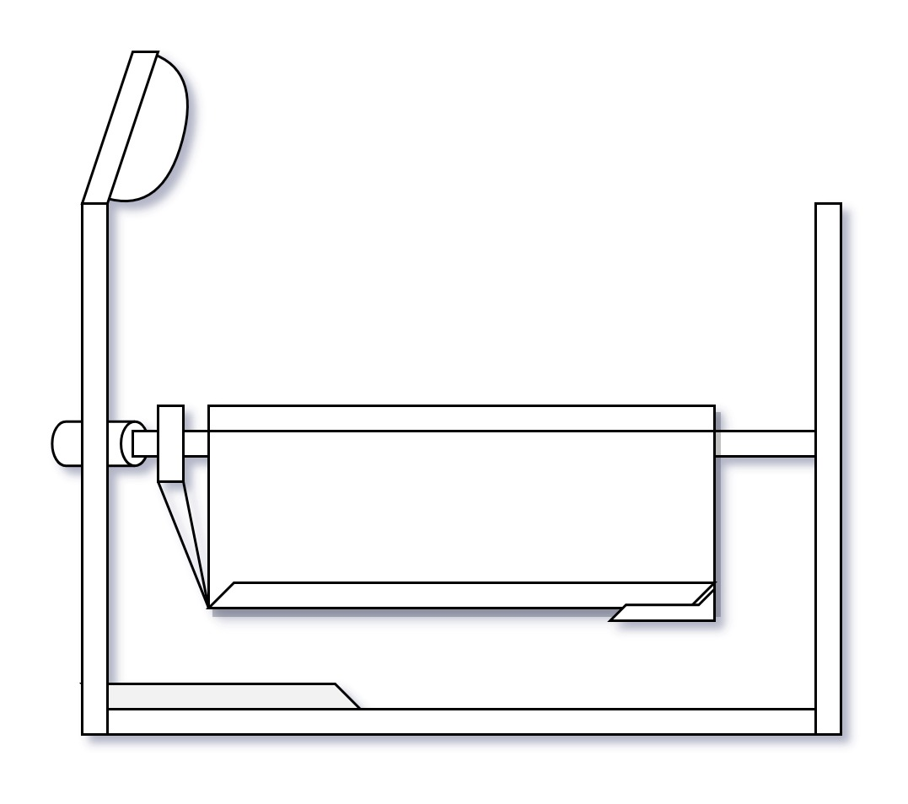

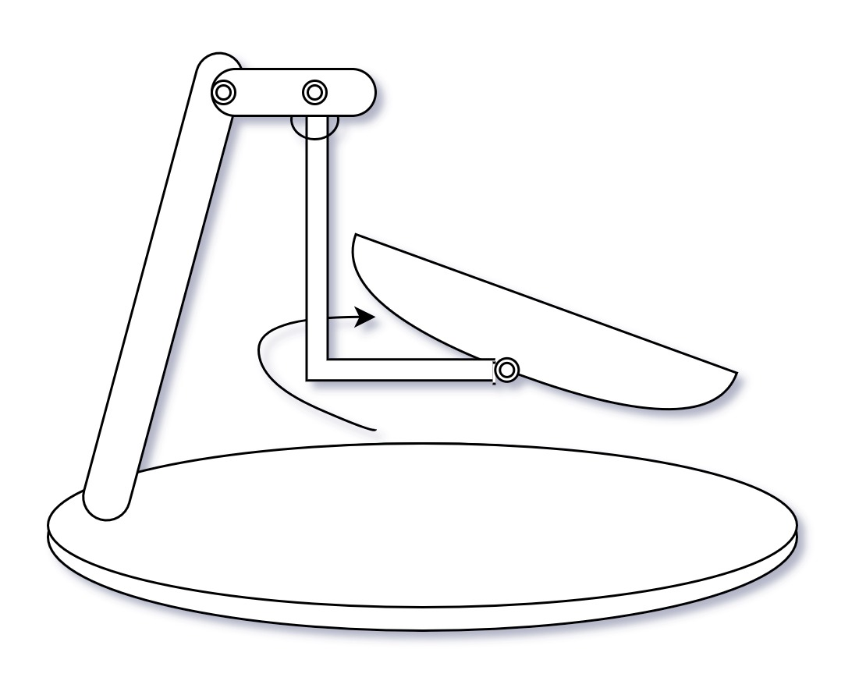

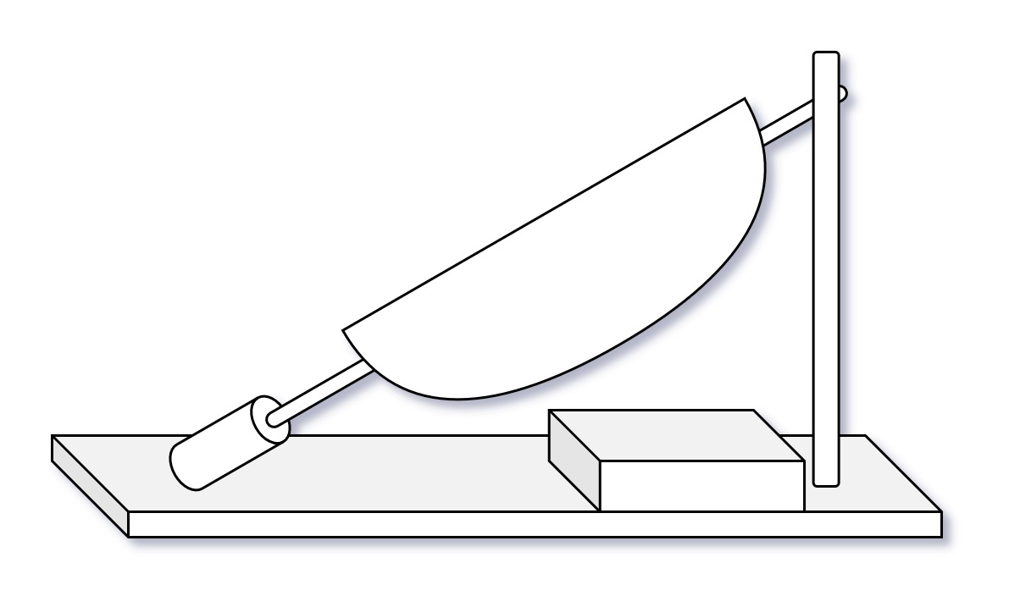

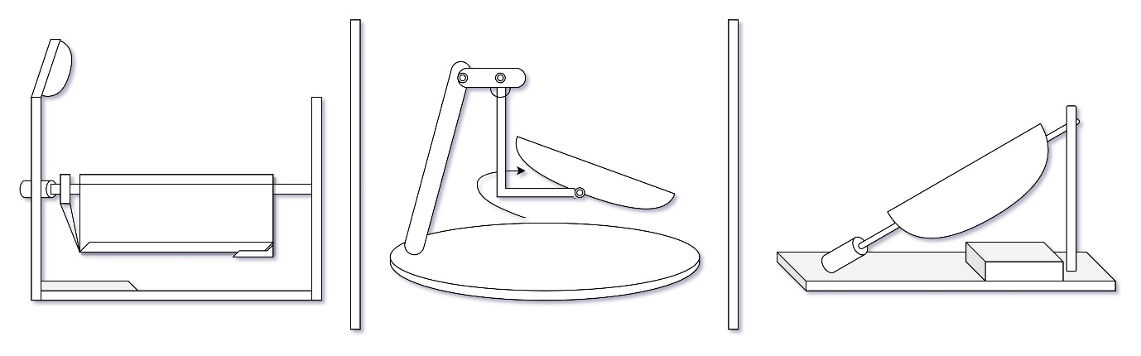

The swing consists of a sturdy frame that supports the seat where the baby sits or lies down. The seat is typically made of a comfortable and secure material like fabric or cushioning. The swing consists of a side handel attached to the seat hub on the swing arms, so the seat will rotate and baby can swing side to side and front to back. The well adjested straps are use for safty and it's like holding it in a mother's arms.

The swinging mechanism converts the rotational motion of the motor into a back-and-forth swinging motion. It typically involves a pivot point or a set of arms that attach to the seat and move it in a controlled manner. A motor is responsible for generating the motion in the swing and offer adjustable swing speeds. It is usually located at the top of the swing frame and is connected to a swinging mechanism. The control signals are sent to the microcontroller, which adjusts the motor's speed and direction accordingly.

A couple of vibe unite is fixed in the bottom of the swing to enhance the calming effect. The vibe unite can be controlled through the microcontroller or the user interface to feels soft massage which can reduce crying and fussiness, support more restful sleep, and alleviate common wail-inducers like constipation and colic.

The bed is equipped with a mechanism for repositioning a rigid body with a flexible sheet to alleviate bedsores and other ailments. A mechanism for raising and lowering the height of baby bed.

Motion sensors can detect the baby's movements and provide data to adjust the swing motion or activate safety features.